CANB Grant Program

Digitization, Migration, or Reformatting of Audio-Visual Material

2026 – 2027

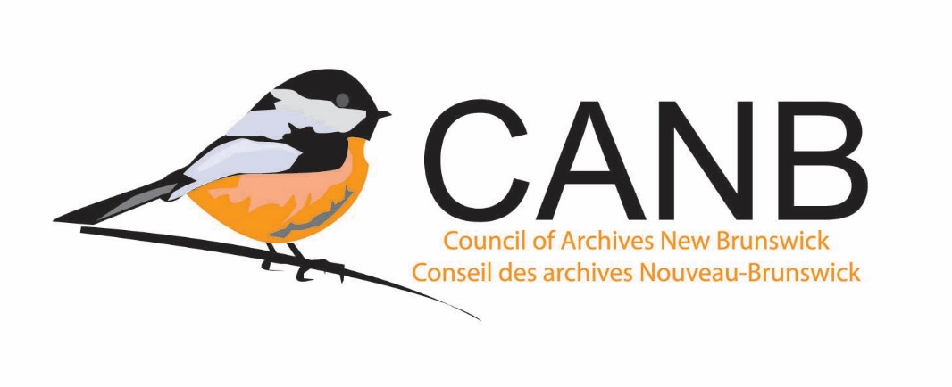

Application Form

1.0 General Information
Name of Institution

Project Lead

Phone #

Email Address

Civic Address

Website

  - Is your Institution’s Mission Statement / Mandate on file with CANB?
- Yes
- No
- It’s been updated and submitted.

  - Was this application reviewed by or discussed with the Archives Advisor?
- Yes
- No

2.0 Project Proposal
Project Title

Proposed Start Date

Proposed Completion Date

2.1 Describe the project.
- Describe the records your institution wants to digitize, reformat, or migrate.
- Why does your institution want to digitize, reformat, or migrate these records? For example, is the information inaccessible due to the format? Is the physical carrier the recording is on deteriorating?
- How does your institution plan to store the newly digitized, reformatted, or migrated records?
- How does your institution plan to use the records once they are digitized, reformatted, or migrated? For example, will the recording be used by researchers, in an exhibition, for educational purposes, etc?
- Who are your project partners? (If applicable)

2.2 When were the records donated to your institution?

2.3 Does your institution have a Deed of Gift for the records?
- Yes
- No
- Its complicated

2.3.1 If you answered It’s complicated, please explain why.

2.4 In the Deed of Gift, was the copyright of the records transferred to your institution?
- Yes
- No

2.5 In the Deed of Gift, were other rights (display, migration, and / or publication (online and in print)) of the records transferred to your institution?
- Yes
- No
- Not sure

2.6 Have you completed the Request for Sound and Moving Image (SMI) reformatting form in consultation with the staff of the Sound and Moving Images Division of PANB? (Please attach the SMI reformatting form when you submit your application).
- Yes
- No

3.0 Budget

Total cost of digitization, reformatting, or migration

1 | Total Amount Requested from CANB  (CANB can cover up to 50% of the cost)
2 | Contributions to project from other sources  (i.e. funds from other institutions, businesses)
3 | Total Amount to be Covered by Your Institution

4.0 Other

4.1 Is there anything else your institution wishes the Adjudication Committee to know about regarding this application?

